B.Tech(ECE)-QUANTUM UNIVERSITY-1-Task4- Develop a C-K theory for optimization

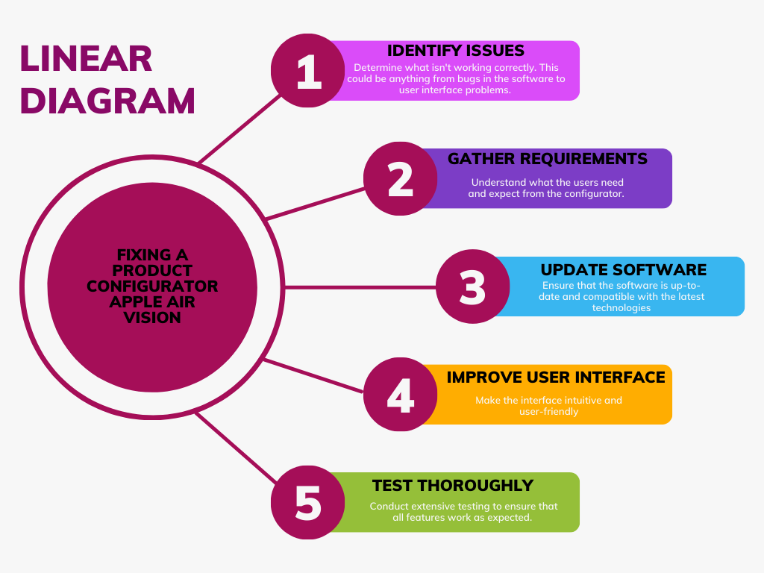 TASK 4